03 · Project Description & Feature Overview
Project: StaffSync — Modern HR Management Solution (MERN)

1. Project Summary
StaffSync centralizes people operations (employee records, leave, attendance, announcements and training) in a single responsive web application. Each user signs in once and is routed to a workspace tailored to their role, so every person sees only the features and data they are entitled to.
Goals
- Replace spreadsheets and paper forms with a secure digital HR workflow.
- Give employees self-service access to leave, attendance and personal records.
- Give HR and managers real-time visibility for approvals and planning.
- Keep communication consistent through organization-wide announcements.

2. Feature Map
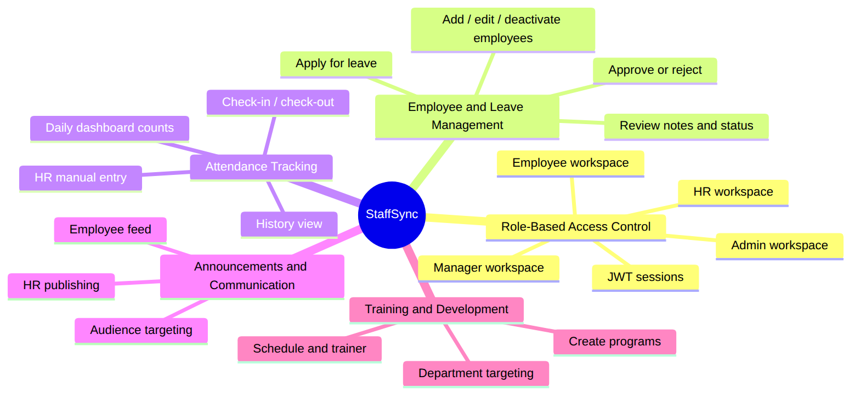

3. Core Features

3.1 Role-Based Access Control
The system provides dedicated dashboards and permissions for HR, Managers and Employees (plus Admin), ensuring secure and role-specific access to features and data.
- JWT authentication with 7-day sessions.
- Backend allowRoles guard on every sensitive endpoint, and role-filtered navigation in the UI.
- Privileged roles can only be self-registered with a private ROLE_SETUP_CODE.
- Login also validates that the selected role matches the account’s assigned role.
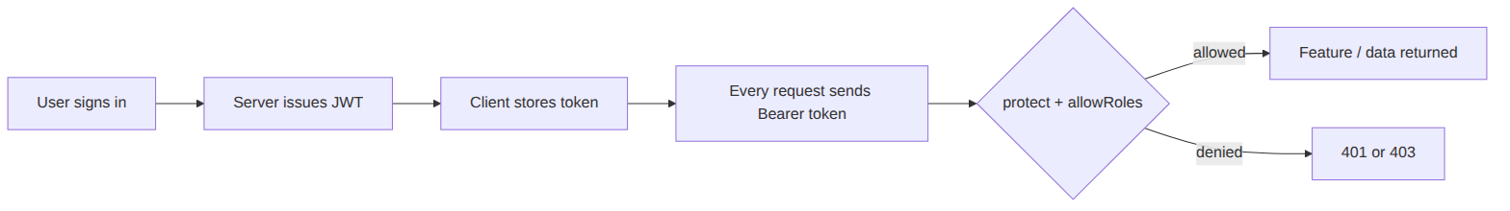

3.2 Employee & Leave Management
HR can easily add, edit or deactivate employee records, while employees can apply for leave digitally. Managers and HR can review, approve or reject requests with real-time status updates.
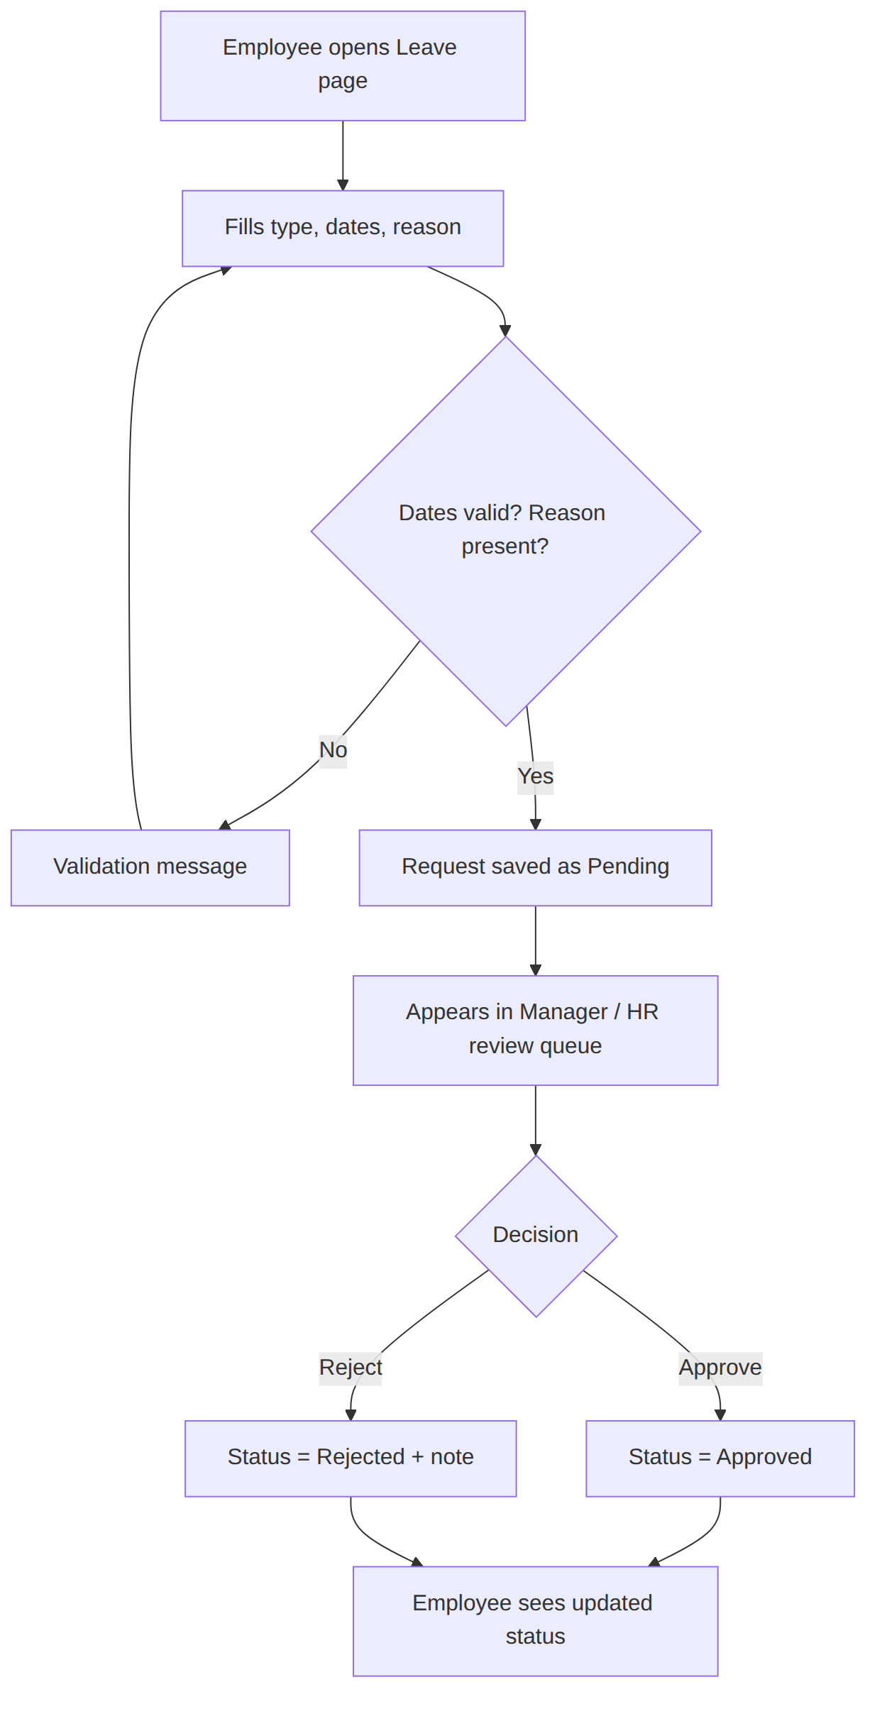

3.3 Attendance Tracking & Reporting
Integrated attendance management allows employees to mark attendance, and HR can monitor daily records to support performance and payroll analysis.
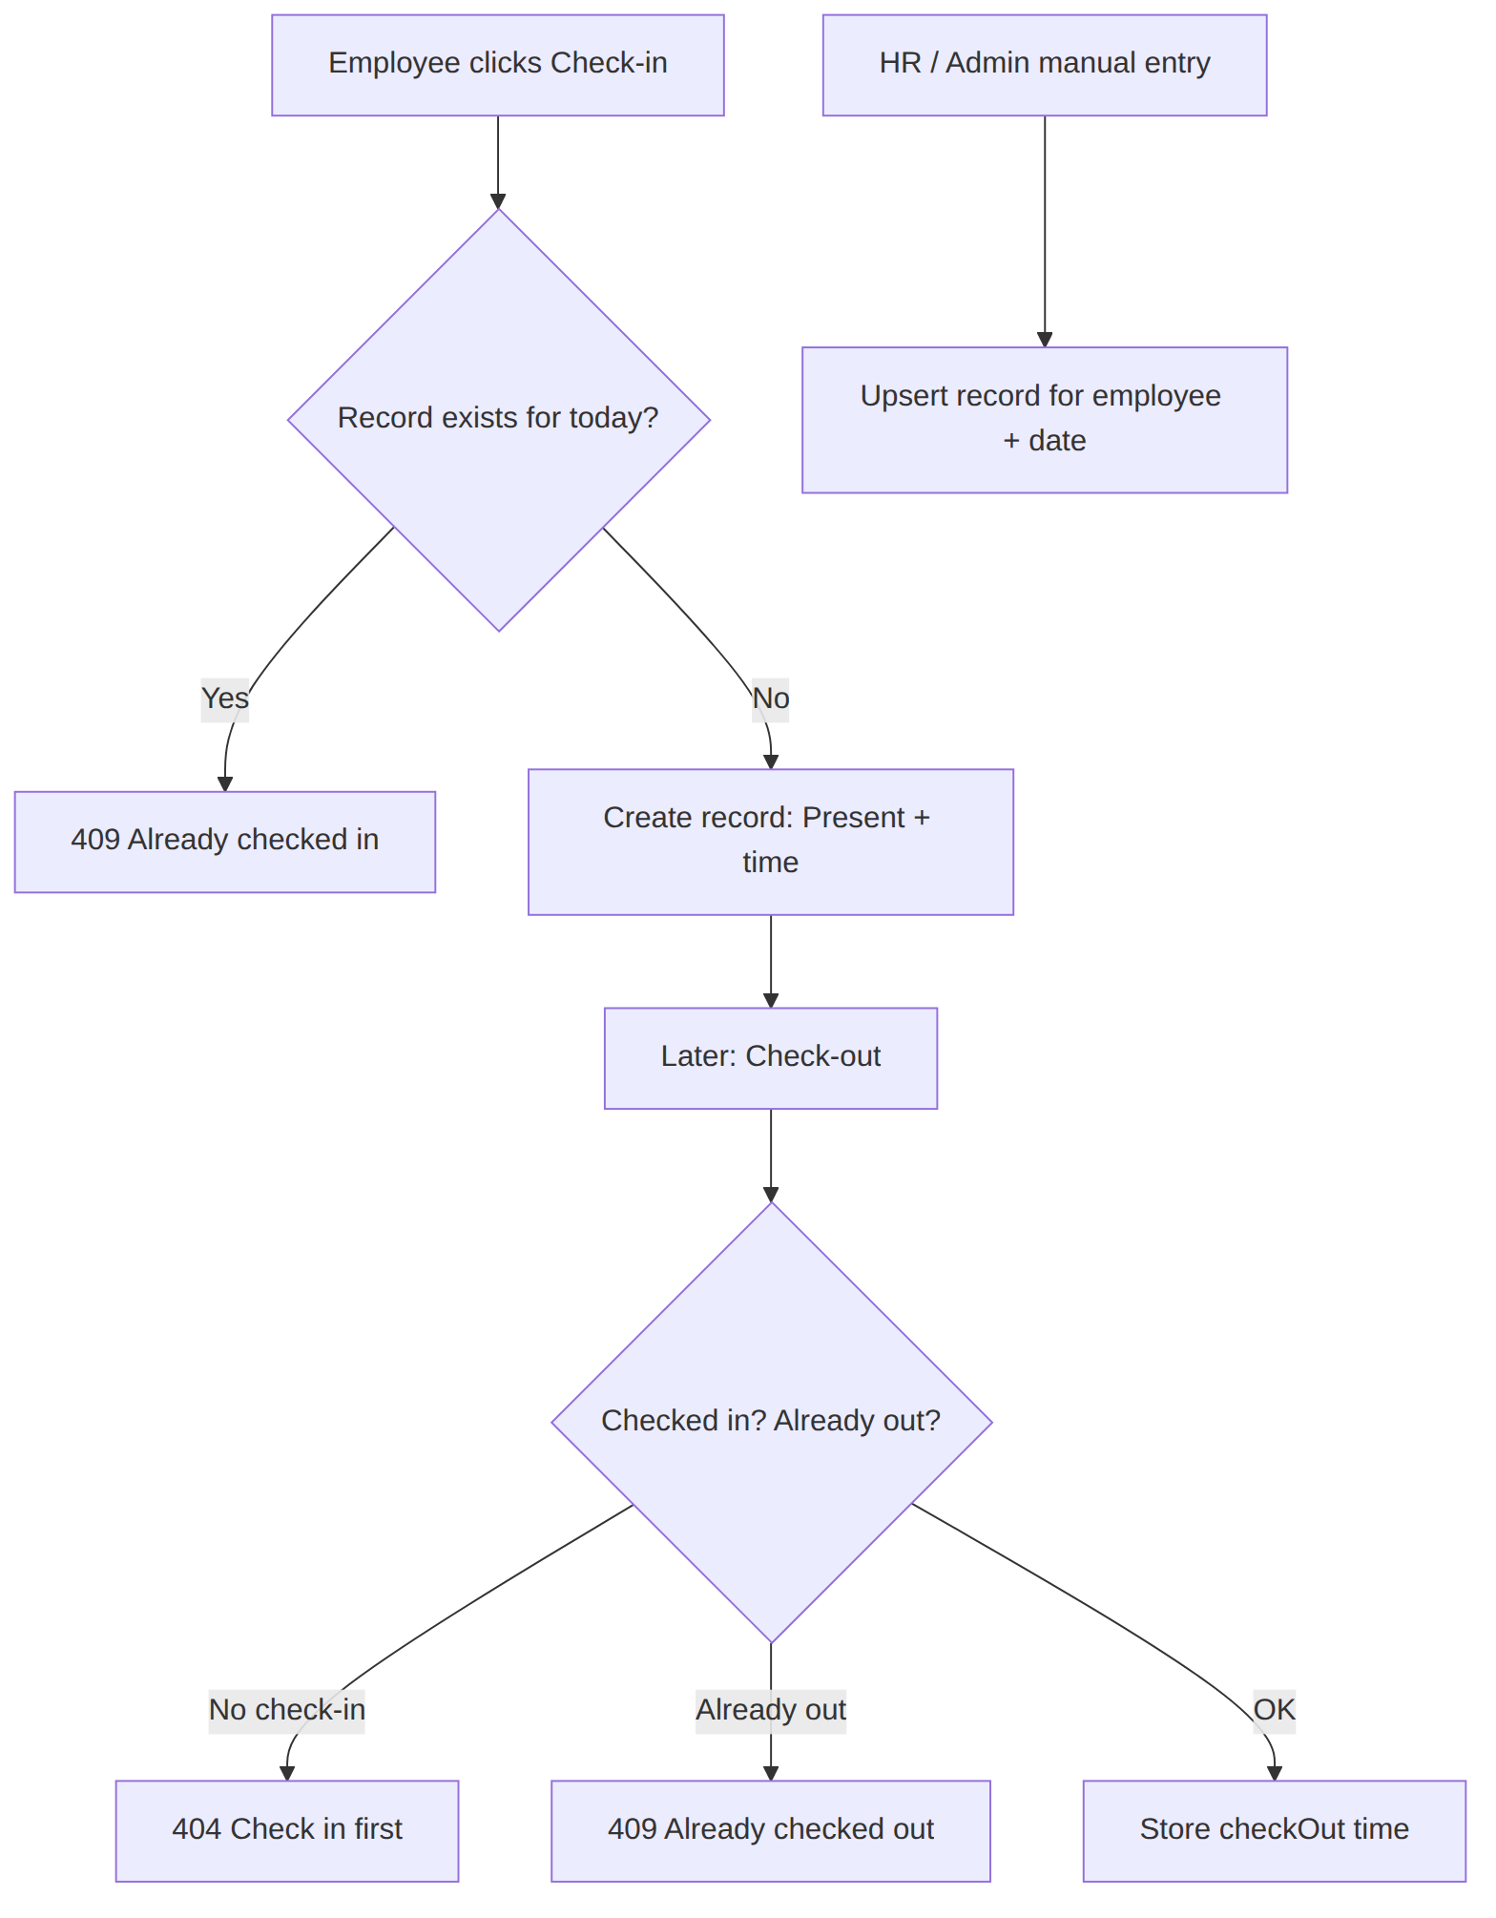

3.4 Announcements & Internal Communication
HR and admins post important updates, company news or event notifications. Each announcement targets an audience (Everyone, HR, Managers, Employees) so that users only see relevant content.
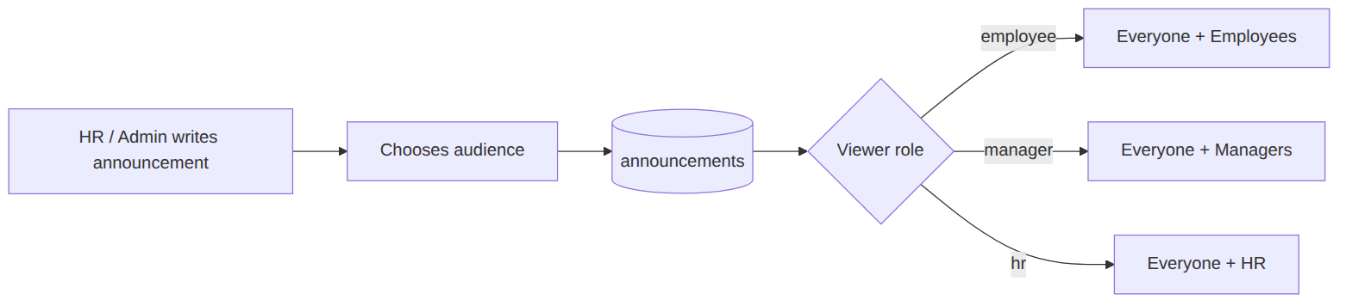

3.5 Training & Development
Managers, HR and admins create training programs with title, trainer, date, duration and department. All users can view the upcoming schedule.

4. Additional Capabilities
Capability | Description
Landing page | Public marketing page where visitors pick a role before login or registration
Dashboard statistics | Employee count, today’s attendance, pending leaves, announcements, upcoming trainings, personal counts
Profile management | Users update name, phone and department
Responsive UI | Light pastel theme, mobile sidebar with scrim
Admin bootstrap | npm run create-admin CLI creates or promotes the first admin
Index self-healing | Server removes obsolete attendance indexes on startup

5. Technology Stack
Layer | Tools
Frontend | React 18, Vite 6, React Router 6, Axios, lucide-react
Backend | Node.js 20+, Express 4, JSON Web Token, bcryptjs, cors, dotenv
Database | MongoDB Atlas, Mongoose 8
Tooling | nodemon, Git

6. Business Value
- Efficiency: removes manual paperwork and approval chasing.
- Transparency: every leave request carries status, reviewer and note.
- Accuracy: a single attendance record per employee per day.
- Security: least-privilege access by role.
- Scalability: modular models and routes allow new HR modules without rewrites.

